Statement of Environmental Effects

Accompanying a development application for

Akuna 3 Friday drive Woodridge stage 3 Thredbo NSW

At

Lot 272

Oct 2022

Prepared by Greg Lister Southpac Builders

360 Woodburn rd Morton 2538

**Contents**

|  |  |
| --- | --- |
| **Introduction** | **Page 3** |
| **Site description and analysis** | **Page 3,4,5** |
| **Details of proposal** | **Page 6,7** |
| **Clause 4.15 – Matters for consideration** | **Page 7,8,9** |
| **Other considerations** | **Page 10, 11,12** |
| **Conclusion** | **Page 14** |

1. **Introduction**

This statement of environmental effects has been prepared by Greg Lister to accompany a development application for minor internal renovation at Akun 3 Friday dve Thredbo . The property is located lot 272DP 1118419 The application is being lodged by Greg Lister pursuant to Clause 4.12 of the Environmental Planning and Assessment Act 1979.

The proposal has been designed to achieve the relevant provisions and assess the proposed development against the matters for consideration listed under Part 3, Division 1, of the Environmental Planning and Assessment Act, 2021 The report conforms to the requirements of Schedule 1 of the Environmental Planning and Assessment Regulations 2021

* Replace bathrooms
* Replace fireplace
* Replace Kitchen
* Replace laundry
* Replace floorcoverings Paint and decorate

This statement has been prepared having regard to the following documentation:

* Owners scope of work doc
* Working Drawings Abode drafting v3
* Meetings and discussions Mr and Mrs Mike Glen
* Design plans supplied by @Donna verco.com

1. **Site description and analysis**

Being a corner site this to the laneway it offers good access and amenity to the proposed internal work schedule.

**3 Location and property description**

Akuna 3 is one of a 3 adjoined property development on Friday drive Woodridge stage 3 Thredbo village. Akuna 3 being the easterly unit and is 2 floors plus loft , primary facing North to the mountain consisting of ground floor bedroom , ensuite ,laundry and ski and dry rooms.

1st floor living bathroom , kitchen .

Lofted bedroom .

Property of 4 bed licenses.

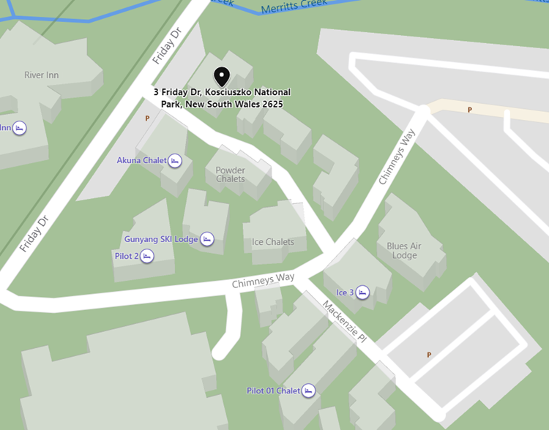

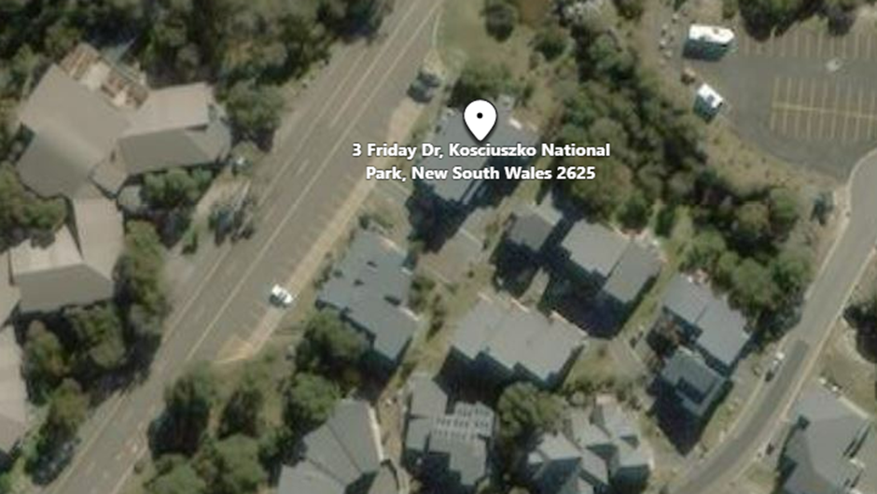

1. **Site characteristics** The site is located on the corner of the lane which provides access to Chalet’s to the east and south .Its central location to ski lifts and amenities makes it a premier position , tourist friendly accommodation.

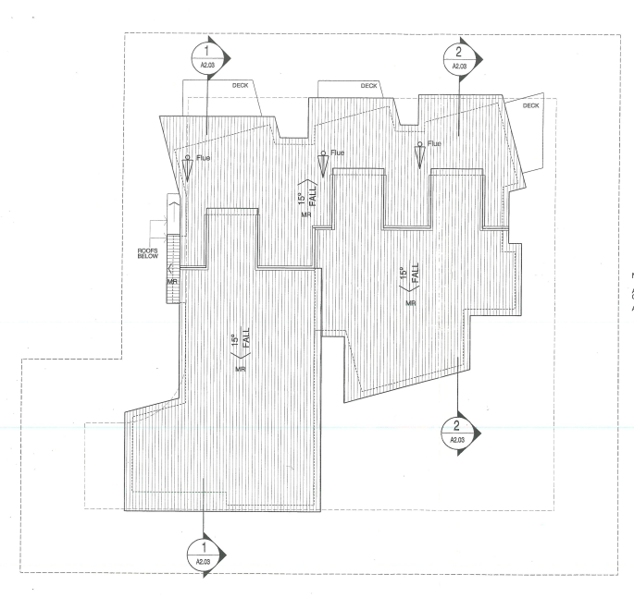

Figure AKUNA 3 ON RIGHT

**5 Surrounding development**

**Below a pic of Akuna 3 and attached development**

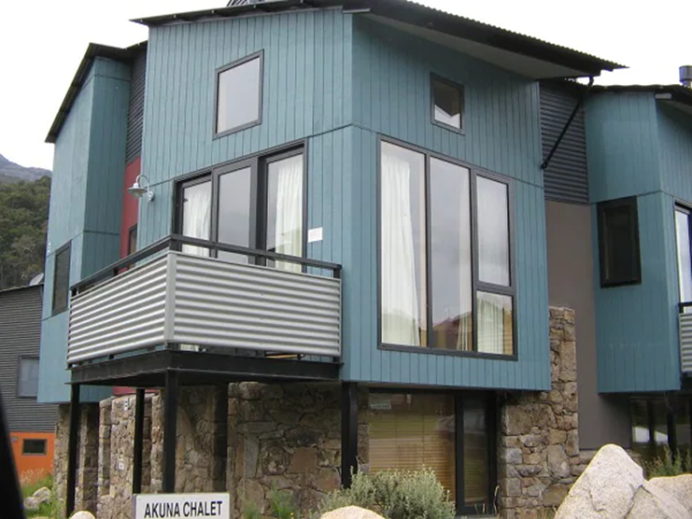

The surrounding developments have all been designed alike using the similar claddings , stonework, and contemporary designs .Allocated parking for all properties is evident both within the property and street frontage offer further amenity.

**Details of proposal**

* 1. **Proposed works**

Ground floor .

1. The ground floor ensuite will be stripped , reinstated with new hardwearing fittings and fixtures selected for aesthetic and energy star rating . The ensuite will be reinstated to the current floor plan lay out .
2. Cabinetry in the ground floor bedroom will be redesigned and installed by a licenced tradesman .
3. The laundry will be stripped out , cabinetry changes and the install of dehumidifier .
4. Minor realignment of a non-structural wall element at the drying room also ground floor
5. The removal of floor tile at the entry and reinstall of heated floor matt type

First floor

1. The Kitchen will be stripped , removed from site and a new kitchen cabinetry and appliances installed by licensed contractor .
2. The carpet will be removed and replaced with hard timber engineered floor , floating type on underlay over existing heated slab in place .
3. The existing first floor bathroom will be demolished and reinstated to a mirror reverse type lay out see new working drawings .
4. Detailed electrical lighting and power supply to bathroom by electrical trades man .
5. Detailed install of all plumbing by licensed trades man .
6. Waterproofing membrane by lic installer to all affected wet areas.\
7. Small nib walls as bed head in loft and all balustrade walls raised to 1100.
8. Carpet up stairs loft
9. Replace renew gas fireplace reusing existing penetration at roof line . Introduce new surround and mantle . see plan
10. Complete job painted to owners specification .

This statement has been prepared having regard to the following documentation:

* Owners scope of work doc
* Working Drawings Abode drafting v3
* Meetings and discussions Mr and Mrs Mike Glen
* Design plans supplied by @Donna verco.com

**6 Environmental planning Assessment**

4.1 ENVIRONMENTAL PLANNING INSTRUMENT.

The applicable Environmental Planning Instrument for the proposed work and applicable to the site is: The State Environmental Planning Policy (Precincts – Regional) 2021, Chapter 4 – Kosciuszko National Park and alpine resorts. The relevant clauses contained within Chapter 4 are listed below:

4.2 PERMITTED OR PROHIBITED DEVELOPMENT. Clause 4.9 - Land Use Table: ‘Tourist accommodation’ with consent is listed as a permitted land use for the Thredbo Alpine Resort. The proposed internal changes do not in any way change the existing permitted and approved use by Akuna 3 as tourist accommodation

**Clause 4.12 Matters for consideration**

|  |  |
| --- | --- |
| **Matter for consideration** | **response** |
| **(1) In determining a development application that relates to land to which this Chapter applies, the consent authority must take into consideration any of the following matters that are of relevance to the proposed development:** | |
| (a) the aim and objectives of this Chapter, as set out in clause 4.1 | The proposed internal alterations are contained within the existing building and will have no impact upon the existing outside environment. The proposed internal alterations are entirely consistent with the aims and objectives set out in clause 4.1 of the SEPP. |
| (b) the extent to which the development will achieve an appropriate balance between the conservation of the natural environment and any measures to mitigate environmental hazards (including geotechnical hazards, bush fires and flooding) | The proposed internal alterations do not create any environmental hazards and will not require any mitigation measures for such hazards |
| c) having regard to the nature and scale of the development proposed, the impacts of the development (including the cumulative impacts of development) on the following: (i) the capacity of existing transport to cater for peak days and the suitability of access to the alpine resorts to accommodate the development, (ii) the capacity of the reticulated effluent management system of the land to which this Policy applies to cater for peak loads generated by the development, (iii) the capacity of existing waste disposal facilities or transfer facilities to cater for peak loads generated by the development, (iv) the capacity of any existing water supply to cater for peak loads generated by the development | The proposed internal alterations will not effect the occupancy of the unit and will therefore not increase the use of any services supplied by the Village. The proposed internal alterations will not affect the capacity of the existing transport, reticulated effluent management system, waste disposal facilities or existing water supply within the Village |
| (d) any statement of environmental effects required to accompany the development application for the development, | Sub Clause (d) is satisfied by this Statement of Environmental Effects |
| (e) if the consent authority is of the opinion that the development would significantly alter the character of the alpine resort—an analysis of the existing character of the site and immediate surroundings to assist in understanding how the development will relate to the alpine resort, | The proposed internal alterations do not involve any external work and will have no effect on, nor alter in any way, the character of the alpine resort |
| (f) the Geotechnical Policy—Kosciuszko Alpine Resorts (2003, Department of Infrastructure, Planning and Natural Resources) and any measures proposed to address any geotechnical issues in relation to the development | Not Applicable |
| (g) if earthworks or excavation works are proposed—any sedimentation and erosion control measures proposed to mitigate any adverse impacts associated with those works | Not Applicable |
| h) any visual impact of the proposed development, particularly when viewed from the Main Range | No increase in activities anticipated because of the proposed alterations |
| k) if the development involves the installation of ski lifting facilities and a development control plan does not apply to the alpine resort: (i) the capacity of existing infrastructure facilities, and (ii) any adverse impact of the development on access to, from or in the alpine resort | Not Applicable |
| (l) if the development is proposed to be carried out in Perisher Range Alpine Resort: (i) the document entitled Perisher Range Resorts Master Plan as current at the commencement of this Policy that is deposited in the head office of the Department and (ii) the document entitled Perisher Blue Ski Resort Ski Slope Master Plan as current at the commencement of this Policy, that is deposited in the head office of the Department | Not Applicable. |
| (m) if the development is proposed to be carried out on land in a riparian corridor: (i) the long-term management goals for riparian land, and (ii) whether measures should be adopted in the carrying out of the development to assist in meeting those goals | Not Applicable |
| (3) A reference in this clause to land in a riparian corridor is a reference to land identified as being in such a corridor on a map referred to in Section 4.4 | |

|  |  |
| --- | --- |
| **Matter for consideration** | **response** |
| 1. Building Height | The proposed internal alterations will have no impact whatsoever on the existing approved building height. |
| 2. Building Setbacks | The proposed internal alterations will have no impact whatsoever on the existing approved building setbacks. |
| 3. Landscaped Area | The proposed internal alterations will have no impact whatsoever on the existing approved landscape |

**7. REGULATIONS**

This development application has been made in accordance with the requirements

contained in Environmental Planning and Assessment Regulation 2021, Part 3,

Division 1, Item 24

**7.1 LIKELY IMPACTS**

**Natural Environment**:

The proposed internal alterations are contained within the existing building and will

therefore, have no impact on the natural environment.

**Built Environment:**

The proposed internal alterations will not change the building footprint or form of the

building and will therefore have no impact on the built environment.

**Social and Economic impacts in the locality:**

The proposed internal alterations will generally improve the use and functionality of

the Unit. The gas fire will reduce air born pollutants and the improved bathroom 3

facilities should increase the guest experience.

**8.1 Visual Impacts**

Nil changes

**8.2 Open Space**

Nil changes

**8.3 Overshadowing and Privacy**

Nil changes

**8.4 Noise**

Nil changes

**8.5 Erosion Control Measures**

Nil changes

**8.6 Economic and Social Impacts**

Construction provides our locals with work opportunities ; the company employs many locals .

**8.7 Environmental Benefits**

Up grading of energy efficient appliances , fittings and fixtures .

**8.9 Security, Site Facilities and Safety**

Whilst in a state of worksite the builder will be responsible for site security .

On site bathroom facilities will be retained for site workers staged to facilitate.

**8.10 Waste Management**

Southpac pl undergo stringent recycle to waste station .

Separating Cardboard , steel , masonry , gyprock from builders waste items .

Dust filtration units in demo .

**8.11 Building Code of Australia**

The Builder is responsible for all trades complying to BCA , legislation and comply with critical site inspections by certifier.

**8.12 Traffic**

The site has good vehicle access. Traffic control officer to manage deliveries heavy vehicles and parking .

* 1. **Stormwater/flooding**

Rare chance of flooding at this site as drainage direct to the Thredbo river is close by and effective.

**9 Site Management**

SITE ENVIRONMENTAL MANAGEMENT PLAN

Akuna 3 Woodridge, Thredbo Village 1

The proposed extent of work is entirely within the existing Unit and does not involve external changes to the building. Hence there is no excavation, earthworks, or other disruption to the site around the building.

The only external impact the alterations will have been during the time the work is being carried out when builders’ vehicles will need to access the site. This plan is intended to appropriately manage:

• Construction vehicle access and parking

• Materials storage

• Removal of construction waste

• Construction hours and working months 2. Access & Vehicle Parking Access to the site is via Friday Drive. Construction vehicles will be able to park within practical access to Akuna 3 Friday drive .

* Material Storage Given the relatively small amount of construction material and fittings required, the storage for all materials will be within the site specific or Southpac shed storage facility KT sheds site
* . No external material storage will be required.
* . Waste Management To effectively manage construction waste generated on site, the following controls will be implemented:
* All construction waste generated on site is to be either stored in the garage or transported out of the Village and disposed of by either re-cycling or taken to the Landfill site outside Jindabyne. No construction waste is to remain on site outside the building at the end of a working day.

• The existing gas burning fire box and the large spa bath which are to be removed are to be recycled if possible rather than discarded to landfill.

• All contractors shall be informed of the need to maintain a clean worksite.

• It is not anticipated any special or unusual fuels or chemicals will be required on site nor will there be a need to dispose of such items.

• All loads of rubbish removed shall be securely covered to ensure no spillage.

• The worksite shall be left in a tidy and rubbish free state upon completion of the works. 5. Construction hours and working months in order to ensure the comfort of visitors and residents during the ski season and to eliminate noise and/or vibration pollution, work is only permitted on site during the months of October through to May. During these permissible working months, the hours of construction are from 7am to 6pm 7 days a week. No construction is to take place from June through to September. 6. Key Emergency Response Contacts In case of an emergency, the appropriate key emergency response contacts should be used:

1. **. CONCLUSION**

The proposed development has been considered in regard to Part 3, Division 1, of

the EP&A Act, 2021 and The State Environmental Planning Policy (Precincts –

Regional) 2021, Chapter 4 – Kosciuszko National Park and alpine resorts) 2021.

The proposal has been found to be consistent with the above legislation and

Environmental Planning Instrument, as detailed in the above report.

The proposed internal alterations are considered to enhance the guests’ amenity and

use of the unit without generating any negative environmental or social impacts and

are considered entirely appropriate